End-User Requirements – EUR-I2302029 Rev 3
  - DBOX ENHANCEMENT
Quick configurator parant and child layout change

Irpinia Kitchens

Document Approval
Approver | Approved Date | Rejected Date | Comments

Part 1: Functionality Overview
- Objectives (Why are we doing this?)
As per Irpinia’s business model, DBOX quick config to be maximum effective when quote is creating by Irpinia’s users or dealers.
- Change the parent/child configurator layout to show the parent configurator properties in a similar fashion to the image presented below
  - Parent options:
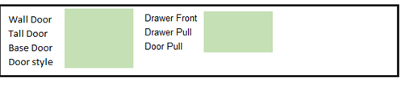
Question:
Does this interface have to be 2 properties per row? Could it just be one property per row? Currently we have a type of parent child conifiguration type, Single Tab Parent child, that supports single column. The other is multiple columns like above, but not necessarily 2 columns.

It can be multi coloumn – i.e. 2 or more MC

  - Child options:
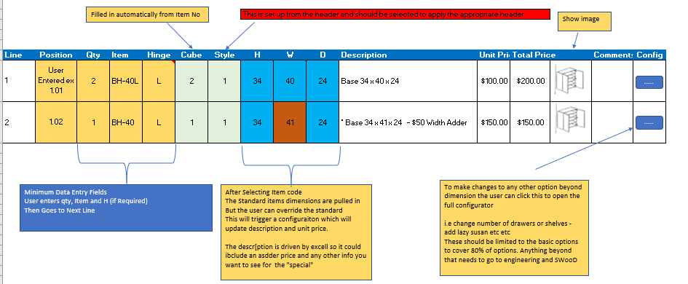

- The user will be able to select the mastered item from the list, example BH-40L. This will automatically field the columns: Item, Hinge, Cube, Stype, H, W, D, and image (file path) will be configurator properties
- The column “ Position” should be empty and editable. The user will add the cabinate position in this field manually. – This will be a configurator property
- The field Hinge to be defaulted to Left and if necessary to be changed manually.
No change: Hinge is a property, and its value is a configured value of the preconfigured (mastered) item and cannot be defaulted by the system. The default value should already be the selected value of the Hinge property.

- The fields H, W and D to be editable in case that the user would like to change some of the parametars.
No change: All property fields are editable unless specified in the setup to uneditable.

- There should be a button that will allow the user to open the child config properties in order to changes something that is not in the main grid.
No change: There already is a button that allows users to see the othe properties.

- Other productlines can be created and associated to the Parent Productline to deal with a variety of user scenarios – such as custom, non defined products
No change: Yes, multiple pre-configured items can be associated to one parent as Parent/Children.

- Enhance DBox to allow selecting any Configurator Property to display regardless of where it is in the property list.
This is not clear. All configurator properties are currently displayed regardless of location. Please provide more information.
Clarification: select which properties to display on the grid – if the full configurator is opened than display all proeratires as normal MC

- Enhance DBox to allow setting the column order for the Child Configurators.
No change: Column order is supported, by using the Screen Postion field in Productline Setup.

- User Roles and Responsibilities
  - Seradex to change the DBOX interface as proposed.
  - Irpinia to create new configurator file to match the proposed DBOX interface configuration.
- Interactions with Other Systems
  - N/A
- Production Rollout Considerations
- Terminology

Part 2: Functional Requirements

Part 4: Change Order Details

Date | Enhancement | Requested By | Notes | Priority | Release Status

Please note that custom reports or searches are not included in the scope of this EUR.

